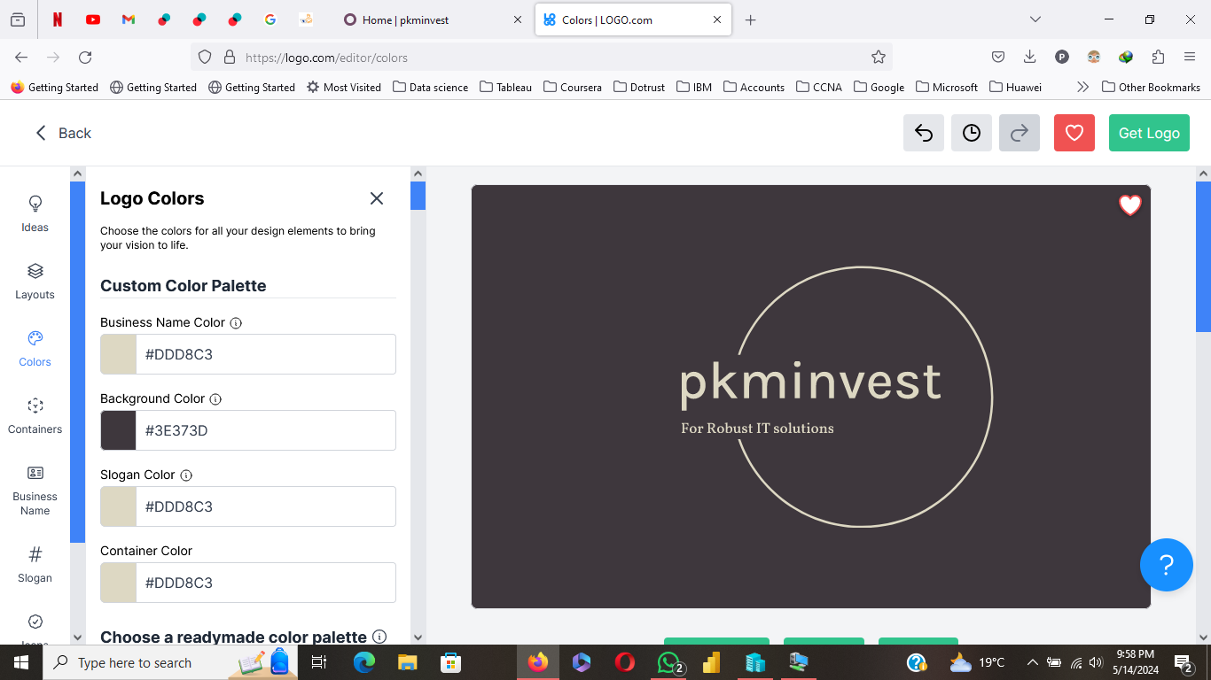

**Business Name Color**

Business Name Color



**Background Color**

Background Color



**Slogan Color**

Slogan Color



**Container Color**

Container Color



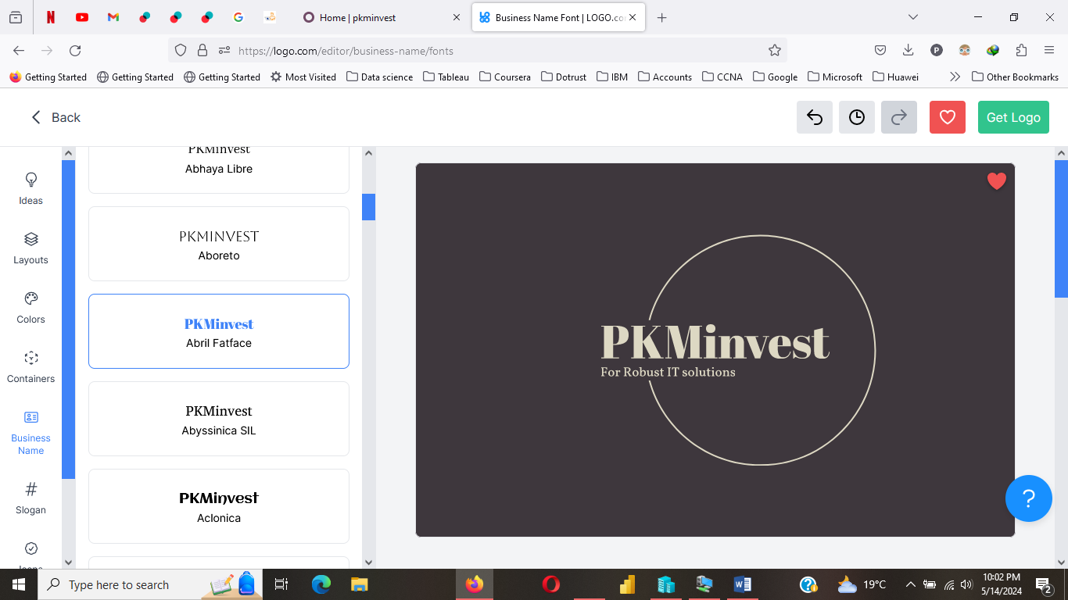

At PKMinvest, we offer variety of services namely: Web design, Digital Training and Data analysis, Survey scripting, Questionnaire design and review, Routine data quality checks